Отчет по 3 главе

3.1.1

CREATE TABLE users(

id INT,

first_name VARCHAR(50),

last_name VARCHAR(50)

);

INSERT INTO users(id,first_name,last_name) values

(1,'Дмитрий','Иванов'),

(2,'Анатолий','Белый'),

(3,'Денис','Давыдов');

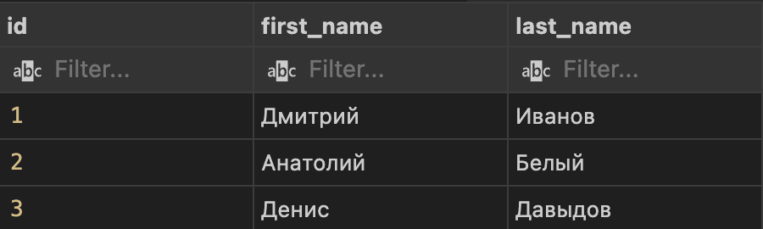

3.1.2

CREATE TABLE orders(

id INT,

state VARCHAR(10),

amount mediumint unsigned

);

INSERT INTO orders(id,state,amount) values

(1,'new',10000),

(2,'new',3400),

(3,'delivery',7300);

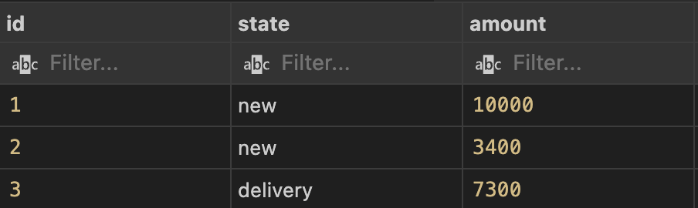

3.1.3

CREATE TABLE users(

id int,

first_name VARCHAR(50),

last_name VARCHAR(50),

birthday date

);

INSERT INTO users(id,first_name,last_name,birthday) values

(1,'Дмитрий','Иванов',19950812),

(2,'Светлана','Демчук',19930708),

(3,'Денис','Антонов',19961223);

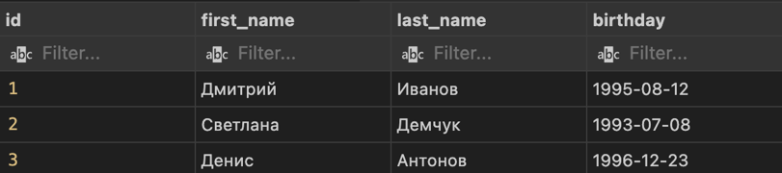

3.1.4

CREATE TABLE messages(

id INT,

subject VARCHAR(100),

message text,

add_date datetime,

is_public bool

);

INSERT INTO messages(id,subject,message,add_date,is_public)

values (1,'Первое сообщение','Это моё первое сообщение !',20161212141600,1);

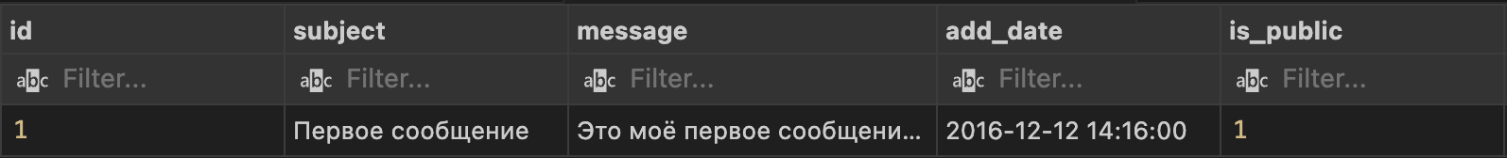

3.1.5

CREATE TABLE rating(

id INT,

car_id int,

user_id INT,

rating FLOAT

);

INSERT INTO rating(id,car_id,user_id,rating) values

(1,1,1,4.54),

(2,1,2,3.34),

(3,2,3,4.19),

(4,2,11,1.12);

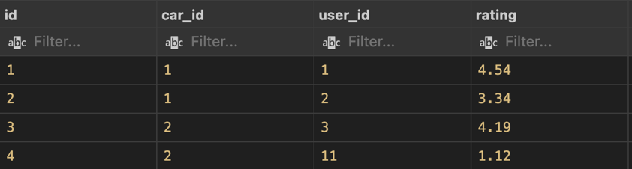

3.2.1

CREATE TABLE products(

id INT,

name VARCHAR(100),

count mediumint unsigned not null default 0,

price mediumint unsigned not null default 0

);

INSERT INTO products (id,name, count, price)

VALUES

(1,'Холодильник', 10, 50000),

(2,'Стиральная машина', 0, 23570),

(3,'Утюг', 3, 7300);

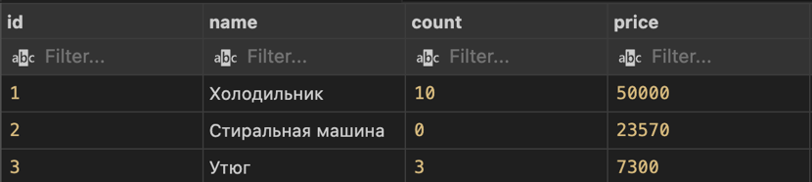

3.2.2

CREATE TABLE orders (

id INT,

product_id INT UNSIGNED,

sale TINYINT UNSIGNED CHECK (sale < 100),

amount DECIMAL(8, 2)

);

INSERT INTO orders (id,product_id, sale, amount)

VALUES

(1, 245, 0,230.50),

(2, 17, 15,999999.99),

(3, 145677, 21,1240.00);

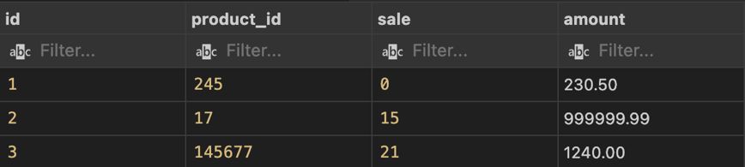

3.2.3

CREATE TABLE films (

id int,

name VARCHAR(100),

rating FLOAT unsigned,

country VARCHAR(2)

);

INSERT INTO films (id,name,rating,country) values

(1,'Больщая буря',3.45,'RU'),

(2,'Игра',7.5714,'US'),

(3,'Война',10.0,'RU');

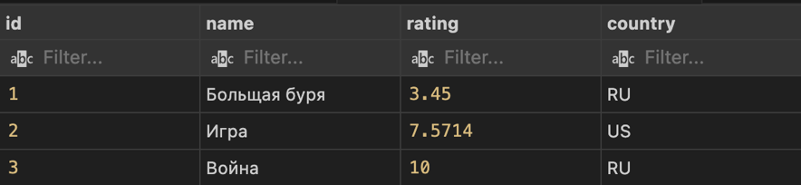

3.2.4

CREATE TABLE files (

id INT,

filename VARCHAR(255),

size BIGINT UNSIGNED,

filetype VARCHAR(3)

);

INSERT INTO files (id,filename, size, filetype)

VALUES

(1,'big_archive.zip', 81604378624, 'zip'),

(2,'movie_37.mp4', 7838315315, 'mp4'),

(3,'music007.mp3', 5242880, 'mp3');

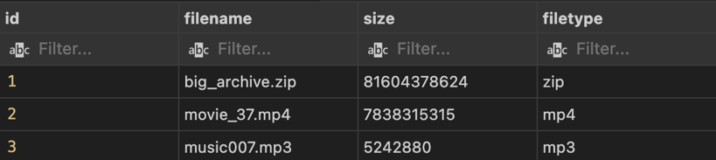

3.4.1

CREATE TABLE users (

id INT,

first_name VARCHAR(50),

last_name VARCHAR(60),

bio Text

);

INSERT INTO users (id,first_name, last_name, bio)

VALUES

(1,'Антон', 'Кулик', 'С отличием окончил 39 лицей.'),

(2,'Сергей', 'Давыдов', ''),

(3,'Дмитрий', 'Соколов', 'Профессиональный программист.');

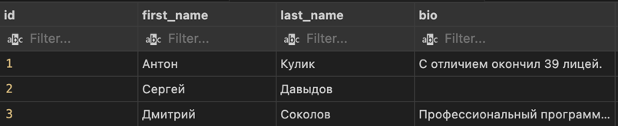

3.4.2

CREATE TABLE books(

id INT,

name VARCHAR(100),

description VARCHAR(1000),

isbn VARCHAR(13) check (char_length(isbn) = 10 or char_length(isbn) = 13)

);

INSERT INTO books (id,name, description, isbn)

VALUES

(1,'MySQL 5', 'Хорошая книга.', '5941579284'),

(2,'Изучаем SQL', 'Полезная книга.', '5932860510'),

(3,'Изучаем Python. 4-е издание', 'Подробная книга о Python.', '9785932861592');

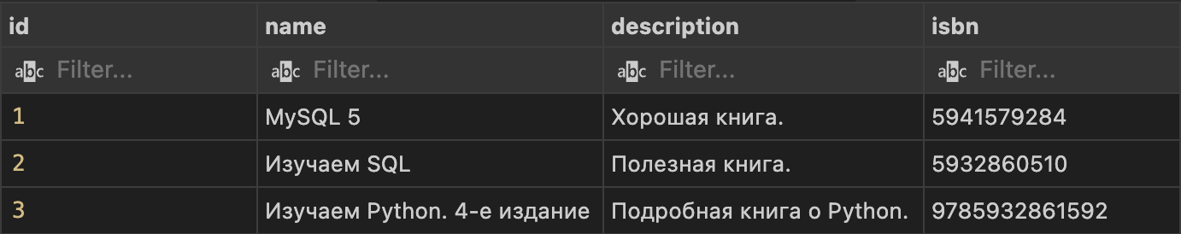

3.4.3

SELECT * from cars

WHERE (mark = 'Nissan' and year > 1990 and power > 120);

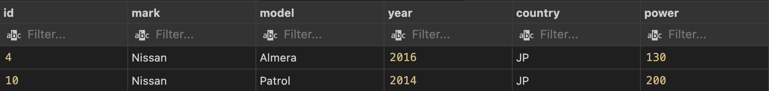

3.4.4

CREATE TABLE apartments(

id INT,

image VARCHAR(100),

price int unsigned check (price <= 99999999),

square int unsigned check (square <= 150)

);

INSERT into apartments(id,image,price,square) value

(1,'/apartments/1/cover.jpg',5250000,90),

(2,'/apartments/2/cover-3.jpg',7500000,103),

(3,'',2300000,56);

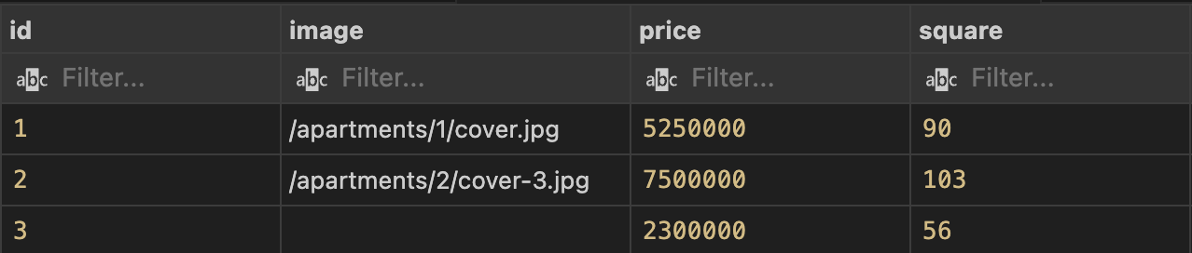

3.4.5

SELECT mark,model,year FROM cars

WHERE (country = 'JP' or mark = 'Peugeot') ORDER BY year DESC;

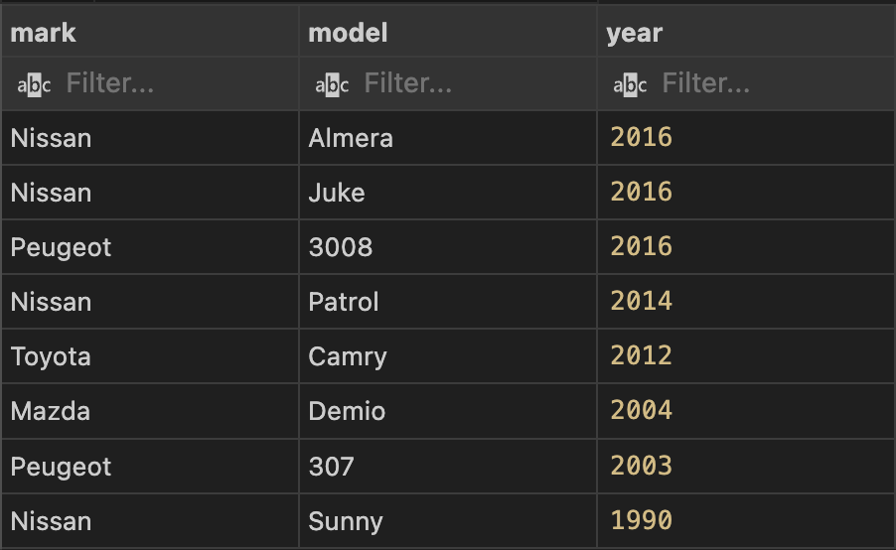

3.4.6

CREATE TABLE files (

id INT,

file_url VARCHAR(500),

file_path VARCHAR(200),

size BIGINT UNSIGNED

);

INSERT INTO files (id, file_url, file_path, size)

VALUES

(1,'http://archives.com/archives/big_archive.zip', 'files/2018/02/archive.zip', 81604378624),

(2,'http://movies.com/movies/movie.mp4', '', 0),

(3,'http://movies.com/best-songs/song.mp3', 'files/2018/03/song.mp3', 5242880);

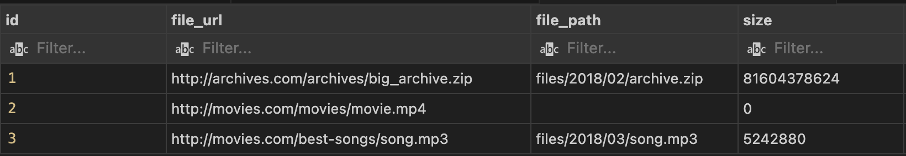

3.5.1

CREATE TABLE users(

id INT,

email VARCHAR(100),

date_joined DATE,

last_activity DATETIME

);

INSERT INTO users (id,email, date_joined, last_activity)

VALUES

(1,'user1@domain.com', 20141212, 20160408123454),

(2,'user2@domain.com', 20141212, 20170213114653),

(3,'user3@domain.com', 20141213, 20170404051207);

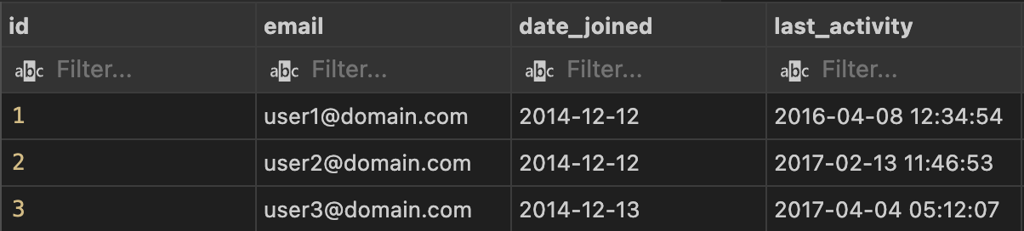

3.5.2

CREATE TABLE calendar(

id INT,

user_id INT,

doctor_id INT,

visit_date DATETIME

);

INSERT INTO calendar (id,user_id,doctor_id,visit_date) value

(1, 1914 ,1 ,'2017-04-08 12:00:00'),

(2, 12, 1, '2017-04-08 12:30:00'),

(3 ,4641, 2 ,'2017-04-09 09:00:00'),

(4, 784, 1, '2017-04-08 13:00:00'),

(5 ,15, 2, '2017-04-09 10:00:00');

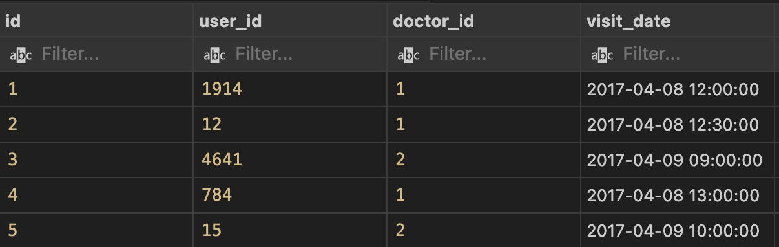

3.5.3

CREATE TABLE temperature(

id INT,

city_id INT,

temperature TINYINT,

wind_speed int check (wind_speed <= 113),

mdate DATETIME

);

INSERT INTO temperature(id,city_id,temperature,wind_speed,mdate) VALUES

(1, 456, 17, 7, '2017-02-08 12:00:00'),

(2, 456, 19, 6,'2017-02-08 12:10:00'),

(3, 456, 20, 6, '2017-02-08 12:20:00'),

(4, 471, -7, 12,'2017-02-08 12:20:01'),

(5, 44, -43, 17,'2017-02-08 12:23:12');

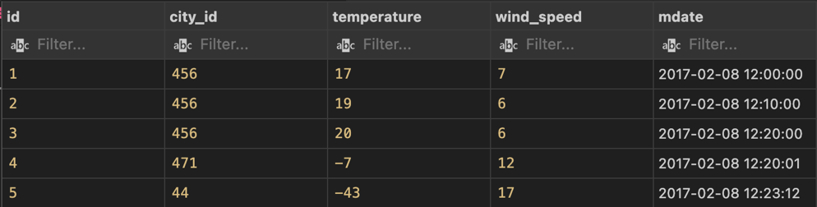

3.5.4

CREATE TABLE arrival(

id INT,

user_id INT,

a_date date,

a_time time

);

insert INTO arrival (id, user_id, a_date, a_time) VALUES

(1, 10, '2017-03-09', '08:45:41'),

(2, 12, '2017-03-09', '08:46:12'),

(3, 7, '2017-03-09', '08:53:01'),

(4, 31, '2017-03-09', '09:01:17');

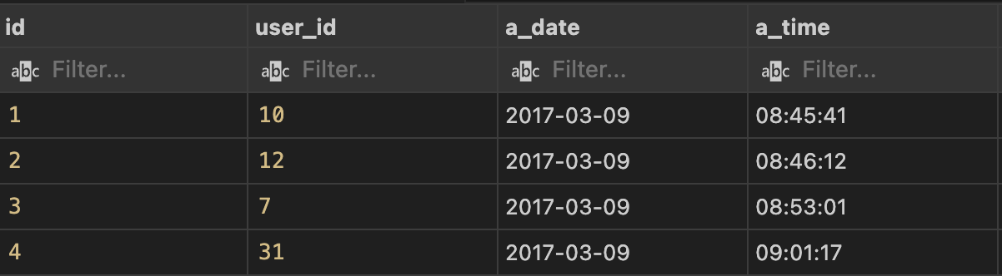

3.5.5

CREATE TABLE cars(

id INT,

mark VARCHAR(20),

model VARCHAR(20),

year year,

mileage int unsigned check (mileage <= 100000)

);

INSERT INTO cars(id,mark,model,year,mileage) VALUES

(1, 'Toyota', 'Camry', 2015, 32000),

(2, 'Mazda', 'CX-5', 2016, 17000),

(3, 'Nissan', 'Patrol', 2016, 60000);

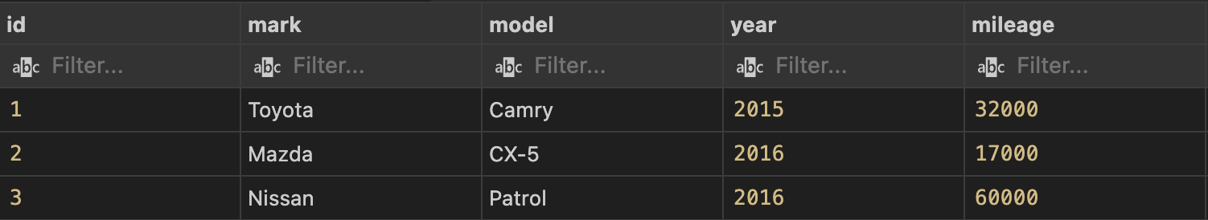

3.5.6

SELECT * FROM cars

where (year = 2016 and mileage <50000);

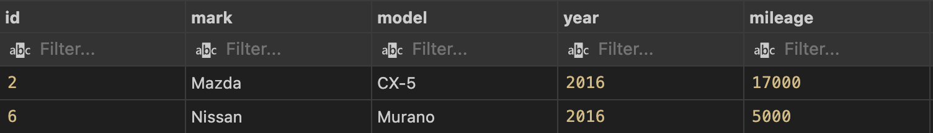

3.6.1

CREATE TABLE users(

id INT,

email VARCHAR(1000) not NULL

);

INSERT INTO users (id,email) VAlues

(1, 'user1@domain.co'),

(2, 'user2@domain.co'),

(3, 'user3@domain.co'),

(4, 'user4@domain.co');

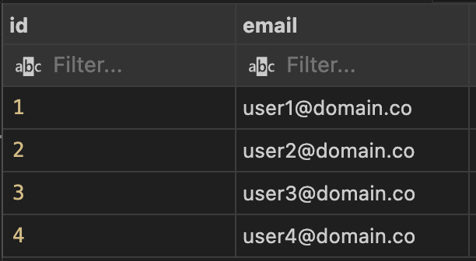

3.6.2

CREATE TABLE products (

id INT UNSIGNED not null,

name VARCHAR (120) not null,

category_id INT UNSIGNED null,

price decimal (10,2) not null

);

INSERT INTO products (id, name, category_id, price)

VALUES

(1, 'Подгузники (12 шт)', 3,700),

(2, 'Подгузники (24 шт)', 3,1250.00),

(3, 'Спиннер', null, 250.40),

(4, 'Пюре слива', 4, 47.50);

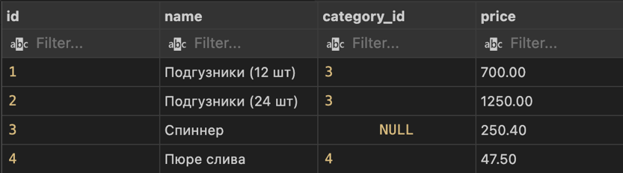

3.6.3

SELECT name,count,price from products

WHERE category_id IS NULL;

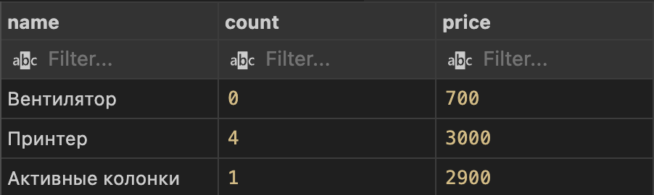

3.8.1

CREATE table articles (

id int unsigned not NULL,

name VARCHAR (80),

text TEXT,

state ENUM ('draft', 'correction', 'public')

);

insert into articles (id, name, text, state)

values (1, 'Новое в Python 3.6', '', 'draft'),

(2, 'Оптимизация SQL запросов', 'При больших объемах данных ...', 'correction'),

(3, 'Транзакции в MySQL', 'По долгу службы мне приходится ...', 'public');

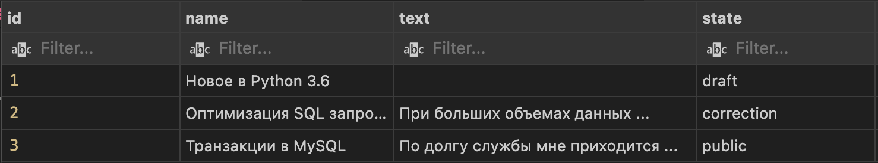

3.8.2

CREATE table rooms (

id int unsigned not NULL,

number tinyint unsigned not null,

beds ENUM ('1+1', '2+1', '2+2') not null,

additional set ('conditioner', 'bar', 'fridge', 'wifi')

);

insert into rooms (id, number, beds, additional)

values (1, 10, '1+1', 'conditioner,bar,wifi'),

(2, '12', '2+1', ''),

(3, '24', '2+2', 'fridge,bar,wifi');

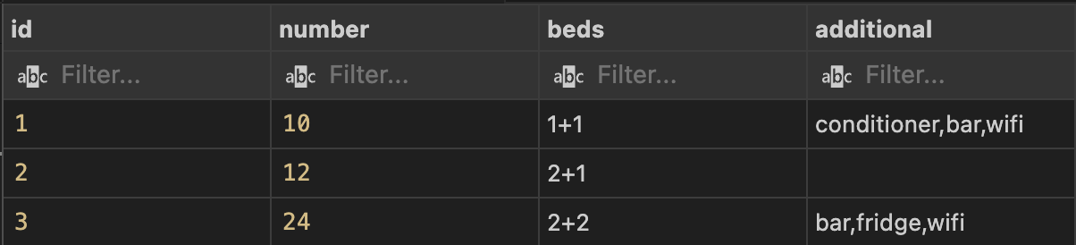

3.8.3

SELECT id, first_name, last_name, birthday FROM users

where pers_info IS NULL or pers_info = 'FALSE';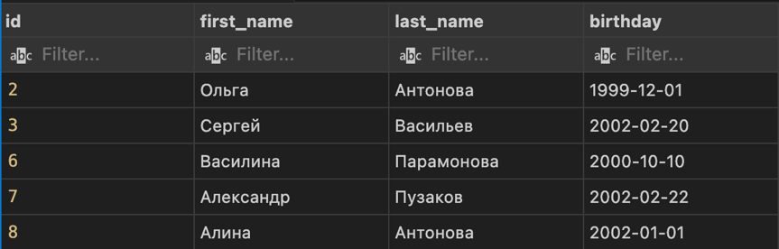

3.8.4

SELECT NAME,price,country FROM products

where count > 0

ORDER BY country, price;

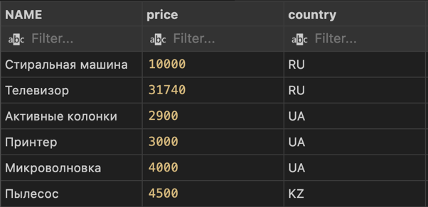

3.8.5

SELECT name, price, country from products

where category_id is NOT NULL and country Like '%RU%' or country Like '%BY%'

ORDER BY price DESC;

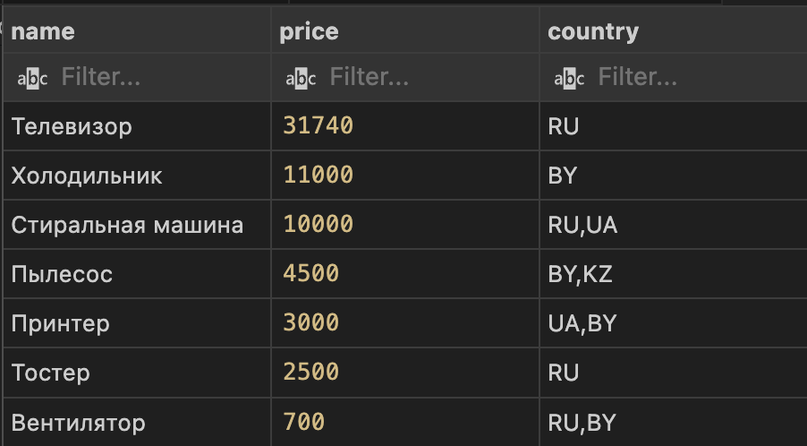

3.8.6

SELECT id, first_name, last_name, birthday, roles FROM users

where sex = 'm' and active = TRUE

ORDER BY last_name, first_name;

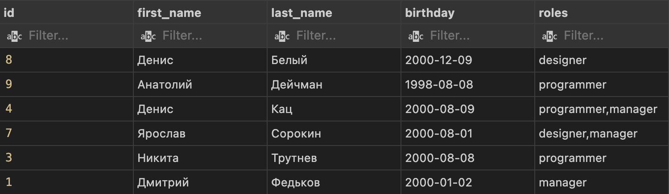

3.8.7

CREATE TABLE orders(

id INT UNSIGNED not NULL,

user_id int UNSIGNED not null,

amount DECIMAL(10,2),

created datetime not null,

state enum('new', 'cancelled', 'in_progress', 'delivered', 'completed'),

options SET('pack', 'fitting', 'call', 'intercom')

);

INSERT INTO orders(id,user_id,amount,created,state,options) VALUES

(456, 763, 14299.00, '2018-02-01 17:45:59', 'completed', 'pack,call'),

(457, 1987, 249.50, '2018-02-01 18:23:04','delivered' ,'pack,intercom'),

(459, 78, 2300.12 ,'2018-02-01 22:12:09' ,'in_progress','');

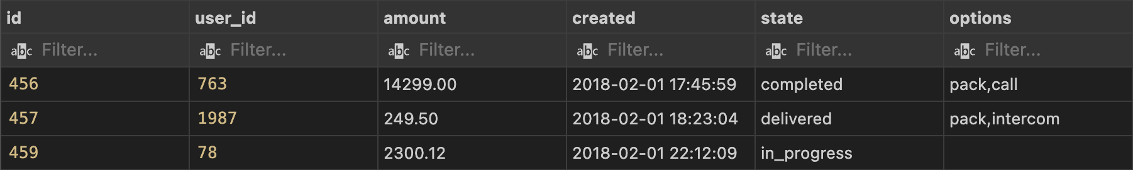

3.8.8

SELECT mark,model, year, power from cars

where country = 'JP' and mark = 'Nissan' and 2010<=year<=2016 and sold = TRUE

ORDER BY power;

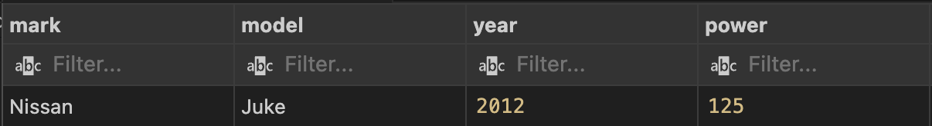

3.10.1

create table orders (

id int unsigned not NULL,

user_id int unsigned not null,

amount mediumint unsigned not null default 0,

created DATETIME not null,

state enum ('new', 'cancelled', 'in_progress', 'delivered', 'completed') not null default 'new'

);

insert into orders (id, user_id, amount, created, state)

values

(1, 56, 5400, '2018-02-01 17:46:59', 'new'),

(2, 90, 249, '2018-02-01 19:13:04', 'new'),

(3, 78, 2200, '2018-02-01 22:43:09', 'new');

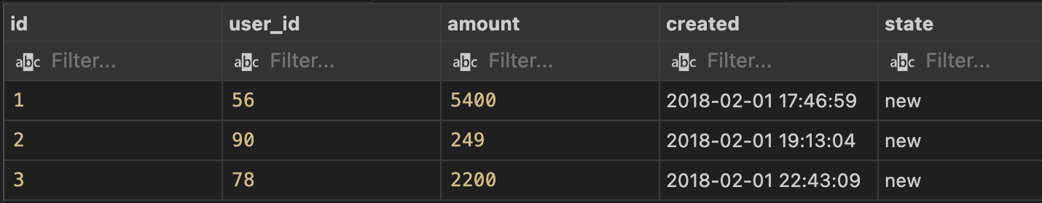

3.10.2

create table users (

id int unsigned not NULL,

first_name varchar (20) not null,

last_name varchar (20) not null,

patronymic varchar (20) not null default '',

is_active bool default TRUE,

is_superuser bool default FALSE

);

insert into users (id, first_name, last_name, patronymic, is_active, is_superuser)

values

(1, 'Дмитрий', 'Иванов', '',TRUE, FALSE),

(2, 'Анатолий', 'Белый', 'Сергеевич', TRUE, TRUE),

(3, 'Андрей', 'Крючков', '',FALSE, FALSE);

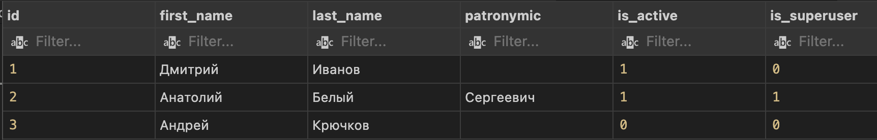

3.10.3

CREATE TABLE products (

id INT UNSIGNED,

category_id INT,

name VARCHAR(100) NOT NULL,

count TINYINT UNSIGNED NOT NULL DEFAULT 0,

price DECIMAL(10,2) NOT NULL DEFAULT 0.00

);

INSERT INTO products (category_id, name, count, price) VALUES

(1,1, 'Кружка', 5, 45.90),

(2,17, 'Фломастеры', 0, 78.00),

(3,NULL, 'Сникерс', 12, 50.80);

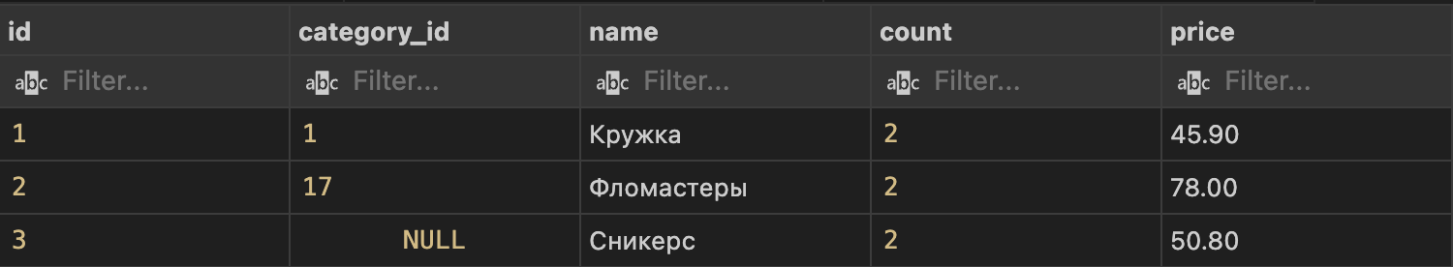

3.10.4

CREATE TABLE logs (

date DATETIME NOT NULL DEFAULT CURRENT_TIMESTAMP,

browser VARCHAR(500) NOT NULL DEFAULT '',

is_bot BOOLEAN NOT NULL DEFAULT FALSE

);

INSERT INTO logs (date, browser, is_bot) VALUES

('2018-03-19 19:50:01', 'Chrome 64.0.1.417', FALSE),

('2018-03-19 19:55:11', 'Firefox 55 (yandex bot)', TRUE),

('2018-03-19 19:56:12', 'Chrome 63.0.0.471', FALSE);

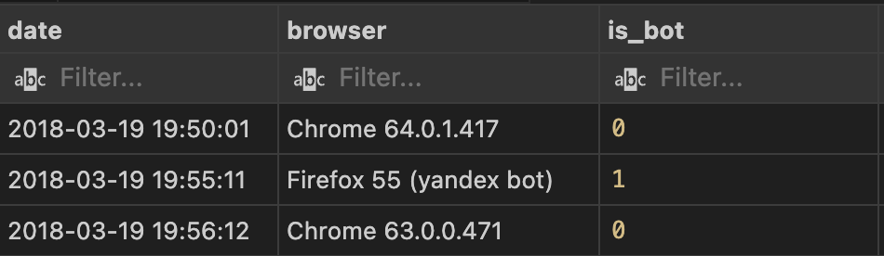

3.10.5

CREATE TABLE reviews (

id INT UNSIGNED,

user_id INT UNSIGNED NOT NULL,

date DATETIME NOT NULL DEFAULT CURRENT_TIMESTAMP,

course ENUM('python', 'sql', 'all') NOT NULL DEFAULT 'all',

text TEXT NOT NULL,

public BOOLEAN NOT NULL DEFAULT FALSE

);

INSERT INTO reviews (id,user_id, date, course, text, public) VALUES

(1,817, '2018-01-11 19:50:01', 'python', 'Это прекрасная возможность получить новые очки в программировании. Доступное объяснение позволяет без проблем изучить желаемый материал', TRUE),

(2,1289, '2018-02-16 08:55:11', 'python', 'Проект на мой взгляд отличный: 1. Короткие видеоролики без воды 2. Интересные задачи и практика 3. Очень быстрая обратная связь', TRUE),

(3,2914, '2018-03-19 12:56:12', 'all', 'Хорошая затея. Но проект ещё нуждается в развитии.', TRUE);

